**IOT Based RFID Student attendance system**

**IOT - Smart Attendance System**

**S.Ganamoorthy , A.Siboshan , S.Hashmithan , C.Prinshiga , T.Chankavi**

Department of Electronics and Computer Science, University of Kelaniya

**\*\*\*\*\*\*\*\*\*\*\*\*\*\*\*\*\*\*\*\*\*\*\*\*\*\*\*\*\*\***

1. **Abstract:**

This research project presents the design and implementation of an IoT-based Smart Attendance System utilizing RFID technology to automate student attendance tracking. Traditional methods of attendance are inefficient and error-prone. This system aims to enhance accuracy, reliability, and data management while ensuring privacy and cost-effectiveness. The methodology involves integrating advanced RFID readers and a centralized database, with encryption to protect data. Initial testing indicates significant improvements over conventional systems, suggesting that IoT-based solutions can revolutionize attendance tracking in educational institutions.

***Keywords:*** IoT (Internet of Things), RFID (Radio Frequency Identification), Smart Attendance System, Educational Technology, Student Attendance Management

1. **Introduction:**

### a)Background

The use of technology in educational institutions has increased significantly over the past few decades. Among the various technological advancements, the Internet of Things (IoT) has emerged as a powerful tool to enhance the efficiency and effectiveness of educational processes. IoT refers to the interconnection of various devices through the internet, allowing them to collect and exchange data. One of the promising applications of IoT in education is the implementation of smart attendance systems.

Traditional methods of taking attendance, such as roll calls or sign-in sheets, are often time-consuming, prone to errors, and easy to manipulate. To address these issues, IoT-based attendance systems, particularly those utilizing Radio Frequency Identification (RFID) technology, have been developed. RFID technology involves the use of electromagnetic fields to automatically identify and track tags attached to objects. In the context of student attendance, RFID tags can be embedded in student ID cards, allowing for automatic recording of attendance when students enter or leave the classroom.

**b)Problem Synopsis**

IoT-based RFID attendance systems have many potential uses, but putting them into practice will require resolving a number of problems and obstacles. The system's accuracy and dependability are a significant problem. Obstacles obstructing the RFID signal or interference from other electrical equipment might cause false positives or negatives. Furthermore, establishing an IoT-based RFID system might be expensive initially, which could be a deterrent for certain educational institutions.

The security and privacy of the data that is gathered is another issue. Since the system tracks students' whereabouts, it is crucial to guarantee that student privacy is maintained and that data is preserved securely. The requirement for appropriate maintenance also exists.

**c)Objectives**

**1)Develop an Efficient Attendance Tracking System**

* Design and implement a robust IoT-based system using RFID technology to automate the process of student attendance tracking.

**2)Enhance Accuracy and Reliability**

* Integrate advanced RFID readers and tags to minimize false positives and negatives.

**3)Improve Data Management**

* Develop a centralized database to store attendance data securely.Ensure the database is easily accessible for authorized personnel while maintaining high levels of data integrity and security.

**4)Ensure Privacy and Security**

* Implement robust encryption methods to protect the data collected from unauthorized access.

**5)Cost-Effectiveness**

* Analyze the initial and ongoing costs of the system to ensure it is economically viable for educational institutions.

**6)User-Friendly Interface**

* Design an intuitive user interface for administrators and teachers to easily monitor attendance and generate reports.Ensure the system is easy for students to use, minimizing disruption to their daily routines.

1. **Literature Review**

Traditional attendance methods, such as manual roll calls or sign-in sheets, have been widely used in educational institutions. These methods, however, are time-consuming, prone to human error, and can be easily manipulated. Various studies highlight the inefficiencies and inaccuracies associated with these traditional methods, prompting the need for more automated solutions.

The advent of the Internet of Things (IoT) has revolutionized various sectors, including education. IoT enables devices to collect, exchange, and process data autonomously. In education, IoT applications range from smart classrooms to automated administrative processes. According to literature, IoT technologies can significantly enhance the efficiency of educational operations by providing real-time data and improving decision-making processes.

Radio Frequency Identification (RFID) technology is a critical component of many IoT applications. RFID uses electromagnetic fields to identify and track tags attached to objects automatically. In the context of attendance systems, RFID tags can be embedded in student ID cards. When a student carrying an RFID tag enters or exits a classroom, the RFID reader captures the tag information, automatically recording attendance. Research shows that RFID-based systems are more accurate and less time-consuming than traditional methods.

Several studies and projects have explored IoT-based attendance systems using RFID technology. These systems generally consist of RFID readers, tags, microcontrollers (e.g., Arduino or Raspberry Pi), and communication modules (e.g., GSM, Wi-Fi). Studies have demonstrated that such systems can streamline attendance tracking, reduce errors, and provide real-time data access. However, challenges such as signal interference, data security, and initial setup costs remain significant.

While IoT-based RFID attendance systems offer numerous advantages, they also present several challenges. Accuracy and reliability are major concerns; obstacles and electronic interference can affect the system's performance. Moreover, the initial cost of implementing an IoT-based system can be high, which might be a deterrent for some institutions. Data security and privacy are also critical issues, as these systems track students' movements and store sensitive information. Ensuring secure data transmission and storage is essential to protect student privacy.

Recent advancements in IoT and RFID technology have led to more sophisticated and reliable attendance systems. Enhanced RFID readers and tags, improved data encryption methods, and cost-effective solutions are being developed to address existing challenges. Future research is likely to focus on integrating more advanced technologies, such as machine learning and artificial intelligence, to further improve the accuracy, reliability, and security of IoT-based attendance systems.

The literature highlights the potential of IoT-based RFID attendance systems to transform attendance tracking in educational institutions. While there are challenges to overcome, ongoing advancements in technology and research are paving the way for more efficient, reliable, and secure systems. Implementing these systems can lead to significant improvements in administrative efficiency and data accuracy, ultimately enhancing the overall educational experience.

1. **Methodology**

**System Design**

1. **Overview**:
   * The IoT-based Smart Attendance System is designed to automate the process of recording and managing attendance using RFID technology and GSM/GPRS for real-time data transmission.
2. **Hardware Components**:
   * **Arduino Uno R3**: The central microcontroller that manages the system.
   * **EM18 RFID Reader**: Reads RFID tags for attendance logging.
   * **16x2 LCD Display**: Displays attendance status and other messages.
   * **MAX232**: Serial communication interface.
   * **GSM/GPRS Module**: Sends attendance data to a remote server.
   * **Power Supply**: Provides necessary power to the system.
3. **Block Diagram**:
   * The block diagram shows the interconnections between the components:
     + The power supply provides 5V to the Arduino Uno R3.
     + The RFID reader (EM18) is connected to the Arduino to read RFID tags.
     + The LCD display is connected to the Arduino for displaying messages.
     + The MAX232 interfaces the GSM/GPRS module with the Arduino for serial communication.
     + 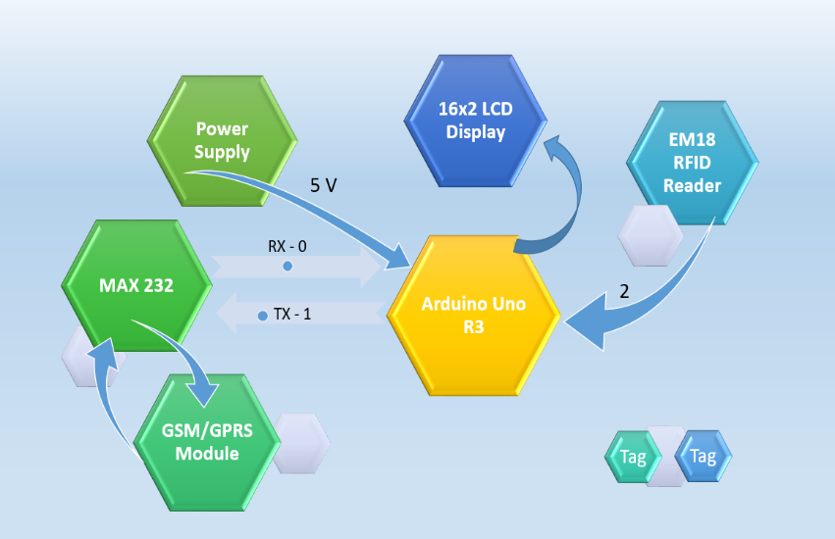

**Implementation**

1. **Hardware Setup**:
   * Connect the EM18 RFID Reader to the Arduino Uno using digital pins for data transfer.
   * Connect the 16x2 LCD Display to the Arduino using appropriate digital pins (D4-D7 for data, RS, and EN for control).
   * Interface the GSM/GPRS module with the Arduino through the MAX232 for serial communication.
   * Ensure a stable 5V power supply to all components.
2. **Software Development**:
   * **Arduino IDE**: Write and upload the code to the Arduino Uno.
   * **Libraries**: Use necessary libraries for RFID, LCD, and GSM/GPRS functionalities.
   * **Code Functionality**:
     + Initialize all components.
     + Continuously read RFID tags.
     + Display the tag information on the LCD.
     + Transmit the attendance data via the GSM/GPRS module to a remote server.

**Security Measures**

* **Data Encryption**: Encrypt data sent over GSM/GPRS to protect privacy.
* **Authentication**: Ensure only authorized RFID tags are recognized.

1. **Timeline**

|  |  |  |  |  |  |  |  |  |  |  |  |  |  |
| --- | --- | --- | --- | --- | --- | --- | --- | --- | --- | --- | --- | --- | --- |
| Activity |  |  |  |  |  |  |  |  |  |  |  |  |  |
| Week | 1 | 2 | 3 | 4 | 5 | 6 | 7 | 8 | 9 | 10 | 11 | 12 | 13 |
| Project Planning |  |  |  |  |  |  |  |  |  |  |  |  |  |
| Literature Review and Requirement Analysis |  |  |  |  |  |  |  |  |  |  |  |  |  |
| Research Methodology |  |  |  |  |  |  |  |  |  |  |  |  |  |
| Detailed System Design |  |  |  |  |  |  |  |  |  |  |  |  |  |
| Hardware Setup |  |  |  |  |  |  |  |  |  |  |  |  |  |
| Software Development |  |  |  |  |  |  |  |  |  |  |  |  |  |
| Database Development |  |  |  |  |  |  |  |  |  |  |  |  |  |
| User Interface Development |  |  |  |  |  |  |  |  |  |  |  |  |  |
| Findings & Final adjustments |  |  |  |  |  |  |  |  |  |  |  |  |  |
| Project presentation & Conclusions |  |  |  |  |  |  |  |  |  |  |  |  |  |

*Table 1: Timeline*

1. **Budget (Estimated)**

|  |  |  |
| --- | --- | --- |
| No | Requirement | Cost (LKR) |
| 1 |  |  |
| 2 |  |  |
| 3 |  |  |
| 4 |  |  |
| **Estimated Total Cost** | |  |

1. **References**
2. Ishaq, K., & Bibi, S. (2023). IoT Based Smart Attendance System Using RFID: A Systematic Literature Review. arXiv preprint arXiv:2308.02591. This paper provides a comprehensive review of various IoT-based attendance systems using RFID technology, highlighting the benefits and challenges of implementing such systems in educational institutions. Available at arxiv.org​ ([ar5iv](https://ar5iv.org/abs/2308.02591))​​ ([DeepAI](https://deepai.org/publication/iot-based-smart-attendance-system-using-rfid-a-systematic-literature-review" \t "_blank))​.
3. Wahab, A., et al. (2019). Smart Parking: IoT and Blockchain. This paper discusses the integration of IoT and blockchain technologies for smart systems, which can be relevant to understanding the security aspects of IoT-based attendance systems. Available at DeepAI.
4. Ibrahim, I. S., et al. (2022). Smart Education: Higher Education Instruction and the Internet of Things (IoT). This paper explores the role of IoT in transforming higher education, including the use of smart attendance systems to enhance learning and administrative processes. Available at DeepAI.